iPictures Directions
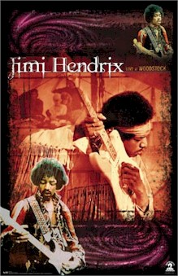
1. New document, 8x10
2. Create a background
3. Insert photos
4. Alter color, scale, effects, etc.
5. Add layer mask
6. Eliminate background
7. Add text
8. Add other effects, drop shadows, borders, etc

Grading Rubric
Following Directions  - At least four photos  - Text  - Layer Masks | 40  20  20
Craftsmanship  - Neatness  - Unity | 20  20
Creativity/originality  - Finished product is not like anyone else’s | 20
Effort  - Thought and effort were obviously applied  - You spent an adequate amount of time  - Added those extra details | 20  20  20
TOTAL | 200

