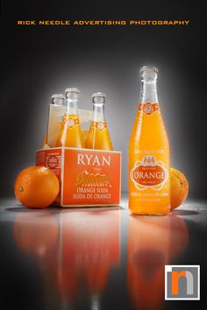
Advanced Photography
Final Photoshop Project
PRODUCT ADVERTISEMENT

Summary: For this final project you will photograph a product and create an advertisement in Photoshop.

Details:
- You will be given a target group and a product type
- You decide on the actual product and layout of the advertisement
- You will create a contact sheet of your photos
- You will create the advertisement in Photoshop

Final Products:
- Contact sheet with at least 10 photos on wiki
- PSD of the advertisement on the wiki

Rubric:
Composition/layout of advertisement – 20 pts
Clarity/quality of photograph(s) – 20 pts
Appeal to the target audience – 20 pts
Photoshop craftsmanship – 20 pts
Text/Readability - 20 pts

